MYLOR BRIDGE BOWLING CLUB

Minutes of the 61st Annual General Meeting held on Tuesday 18th November 2025

Welcome

The Chairman, Elaine Beckton, welcomed those present to the Club AGM. Members stood in a minute’s silence in remembrance of Sue Hill, Charles Robinson, Bill Foote, Mike Diston and Lucie Sulch.

Apologies for absence

Apologies for absence had been received from:- Peter Waller, Mike and Margaret Coe, Janet and David Peacock, Fred and Heather Ward, Kevin and Janella Horne. Adrian Poole, Linda Storey, Penny Cox, Christopher Whiteley, David Gadd and Sarah Curnow.
39 Full and Life members were in attendance, the register taken at the meeting is appended.

Minutes of previous meeting

The minutes of the AGM held on Tuesday 22nd October 2024, including the reports as presented for the 2024 AGM, having previously been circulated to the membership, were accepted as a correct record.

Matters arising from the minutes

No Matters arising

The Chairman’s address

2024 had been quite a year. The Club’s 50th Anniversary… new shirts, commemorative key 2025 has been another busy year and I would like to thank my fellow committee members for their tireless efforts to keep our club running so successfully. Much goes on behind the scenes, on a daily basis, that is often unrecognised.

The upkeep of the green, the clubhouse and its surrounding grounds is undertaken by a handful of men under the guidance of Jeff Askew. Sue Rath, too, spends many hours tending the flower beds. Compliments for all of which, are regularly given by visiting teams. My thanks to each of you for your efforts.

As the year ends and reins are handed over, I would like to thank our captains Sue Kelly and Norman Sancto for the work they have done throughout. A difficult job at the best of times.

The summer season went well with accolades for both the men and ladies sections. I will leave our club captain to avail you of the details. Naturally I offer my personal congratulations to all winners of County, Group and Club competitions. My thanks to Sue Walker for once again organising the club competitions so admirably.

The position of housekeeper is to be vacated by Linda Storey and myself this year and I hope that someone – or a group of people - will step into the breach. The club earns not inconsiderable sums during the season when county and national competitions are hosted. All of which helps to keep our coffers full and the annual subscription down. The task is not too onerous, and I am only too happy to offer guidance if required.

Now a word or two about the 2025 club tour to Cwmbran. We arrived at The Parkway Hotel in the pouring rain but were greeted with a very warm welcome, tea and biscuits. A superb hotel whose staff couldn’t have been more helpful. We won our first match at Hay on Wye, lost the second at Croesyceiliog and drew at Ross on Wye. The club visits were all most enjoyable and the weather held for all but the last game when we played the last two ends in the rain. Andy Lobb kindly entertained us for two nights, the first a quiz and the second musical bingo. Slightly raucous but, as we were in a side room, no other hotel guests were disturbed! We now look forward to 2026 when we will be visiting Worcester.

Finally, my thanks to you all, in particular the committee, for the help and encouragement given to me throughout the year.

The Treasurer’s report

The Financial Report and balance sheet, having previously been circulated to the membership were proposed for acceptance by Sue Walker, seconded by Judy Chinn. Members voted unanimously for approval of the accounts and thanks given to Tony Hill for his management of the club finances.

Despite the difficult economic situation, the Club had coped well. The Committee had therefore decided not to increase subscriptions this year, which would remain at £115 p.a.

A full statement of accounts is included in the attached Treasurer’s Report

Bowls Cornwall AGM.

A short report on the Bowls Cornwall AGM was given by Carole Woodman. This included a resume of the voting on this year’s Propositions, an appeal for more Members to become Coaches and Umpires (training available on line), a reminder of the purpose of Bowls Cornwall Benevolent fund and an appeal for more Members to consider joining the Vice Presidents Association, which raises money for the Benevolent fund and allows Members to play in friendly matches across the County.
From next year, a rule change will be adopted that all competitions must be completed in the year and cannot be carried over.
Full Minutes will be circulated when they become available.

Other reports

Copies of all reports circulated to members prior to the meeting will be attached to the minutes and placed on file – including Club Captain Report and Web update.
There were no questions raised on any of the reports.

General Proposals.

Proposals being placed before the meeting were:-

1) Clubhouse Roof

The Clubhouse roof is known to have a number of small leaks, which if left unattended will result in structural damage to the supporting structure. Unfortunately, the roofing is made of sheeting which contains low grade asbestos. As a result, we cannot legally work on the roof and the only solution is to have the asbestos sheets removed by a company licensed to carry out this work and fit a replacement roof. The Committee felt that when such work was undertaken we should include the installation of solar panels, which would markedly reduce our energy costs and additionally provide a source of income.
Jeff Askew has had initial discussions with Fox Construction based in Perranarworthal, and the likely cost of the total project was estimated to be in the region of £70,000 including VAT. Although the Club has a contingency fund to cover major structural repairs, this is of the order of £25,000 with a similar amount in the Club’s day to day operating account. Clearly, we are not in a position to fund the project even if we forgo the opportunity to install solar panels.
The Committee was due to hold discussions with Paul Bearham, a Member of Chacewater Bowling Club, who has experience of applying for grants to assist with similar projects.
Clearly, the Committee will keep the Membership informed of whatever progress we are able to make.

2) Cleaning Rota

As a Club, we rely on Members to undertake certain basic tasks rather than employ outside help in order to keep the Membership fees as low as possible. The Cleaning rota is one such example and involves all Club Members in keeping the Clubhouse and changing rooms clean and tidy by giving up a small amount of their time two or three times a year to undertake basic cleaning duties. Unfortunately, a number of Members either do not fulfil this obligation or forget to arrange a replacement when they are unavailable to undertake their allotted turn.
The rota is clearly displayed in the Clubhouse and on the Website, and Members were reminded to check when they were due to attend or to find a replacement to stand in for them.

3) Catering

Both the Catering Co-ordinator and Assistant Catering Officer had resigned this year and we have had no volunteers come forward to take on these roles. A number of Members regularly assist when catering is required, but we do need someone to act as an organiser and focal point for catering activities. This is a vital role from which we all benefit and can be undertaken by a man or a woman. An urgent appeal was made for Members to take on these important roles.

4) Friendlies

Recently the Club has struggled to get sufficient Members to sign up to play in Friendly Matches. The opinion had been expressed that too many Friendlies were booked later in the season when many Members were already involved in other competitions. Members were generally unenthusiastic about Friendlies and the general feeling was that we needed to look at different scheduling and probably reduce the number of Friendlies that we currently undertake.

5) Club Jackets

Interest had previously been shown in the Club having an agreed design of a waterproof over-jacket. An example of a possible design was available to see, but did not meet the anticipated needs and further investigation was needed.

6) Club Tour 2026

It had been proposed that the Club tour for 2026 would be to Worcester in September. Despite recent very successful tours, the response had been disappointing. At the time of the meeting,we had just enough for the tour to go ahead, but if anyone were to pull out it would be difficult to keep it viable. A request for more Members to join the tour was made.

Club Charity 2025-2026

Mike Coe had proposed that the Club support the Mylor Bridge Playing Fields Association for the coming year. This was seen as an excellent local Charity and accepted in principle to be adopted for the coming year.

Life Membership

From time to time, the Club awards Life Membership to long-standing Members who have made a significant contribution to the Club both as Players and in Club support roles.
This year two Members, Derek Shermon and Keith Duff were granted Life Membership. Both have been Members for many years and have enjoyed successful Bowling careers, which continue to the present.
Derek served a distinguished period as Honorary Secretary and is a Trustee for the Club, and Keith is a major player in the Club working party where his expertise in construction projects has been an invaluable asset to the Club over many years.
Our thanks and congratulations to both of them.

Election of Executive Officers

The following Officers were unanimously elected, unopposed to office having been duly nominated and seconded: -
President Derek Shermon
Chairman Elaine Becton
Hon. Secretary David Woodman
Hon. Ladies Secretary Carole Woodman
Hon. Treasurer Tony Hill
Hon. Match Secretary Anthony O’Sullivan
Men`s Section Captain Andrew Lobb
Ladies Section Captain Sue Kelly
Greenkeeper Jeff Askew
Ladies Rep. Leticia Rivett-Old
Men`s Rep. Post-Meeting note:- David Gadd had agreed to serve.

The members of the club all wish to express their thanks to all the outgoing members of the Executive committee that have stood down this year.

Election of Non-Executive Committee Officers

Strollers Team Manager. Wendy Fowler
Club Almoner Margaret Green
Bar Manager Richard Griffin
Competitions Secretary Sue Walker
Publicity Manager Elaine Becton
Website Manager (s) John French (Ian Dodd)
Safeguarding Officer Sue Kelly
Carpet Bowls Co-ordinator Sue Kelly
Short Mat Bowls Co-ordinator. David Gadd
Catering Co-Ordinator Post-Meeting note:- Linda Strelzyn had agreed to serve.
Catering Officer Assistant Vacant

Any other Business

Andy Lobb reported that Mylor Bridge had a team playing Darts at Falmouth Bowling Club and doing very well. It was suggested that Mylor Bridge should arrange to provide similar playing facilities in our Clubhouse which would offer not only the opportunity for Members to play on this site, but would also add extra revenue for the Club from Bar/catering income. The meeting agreed to support this initiative.

There being no further business, the meeting closed at 8.40pm

Chairman …………………… Date……
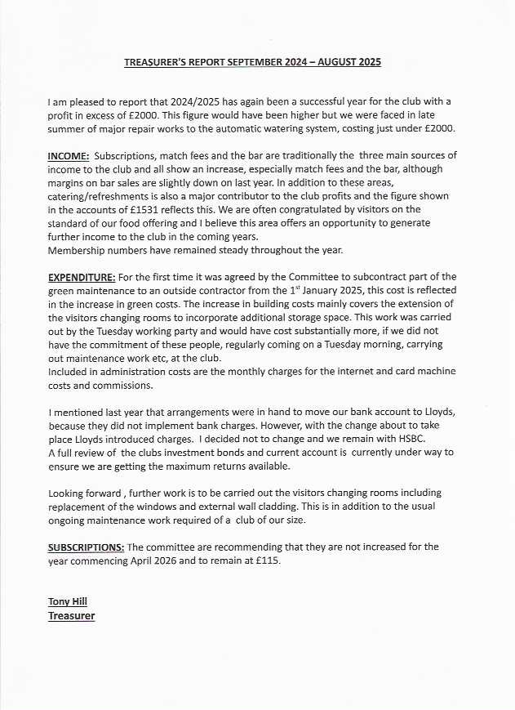
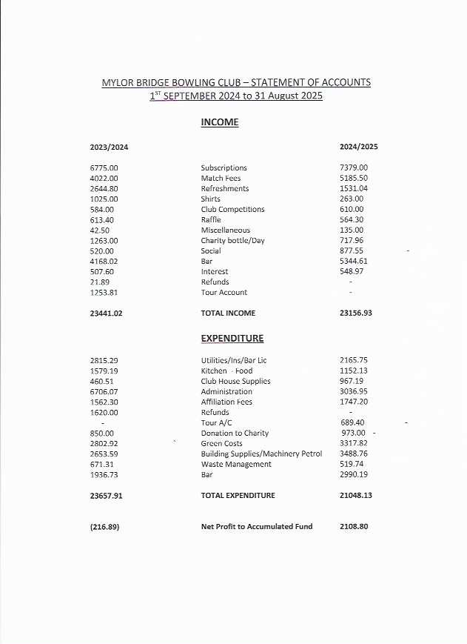
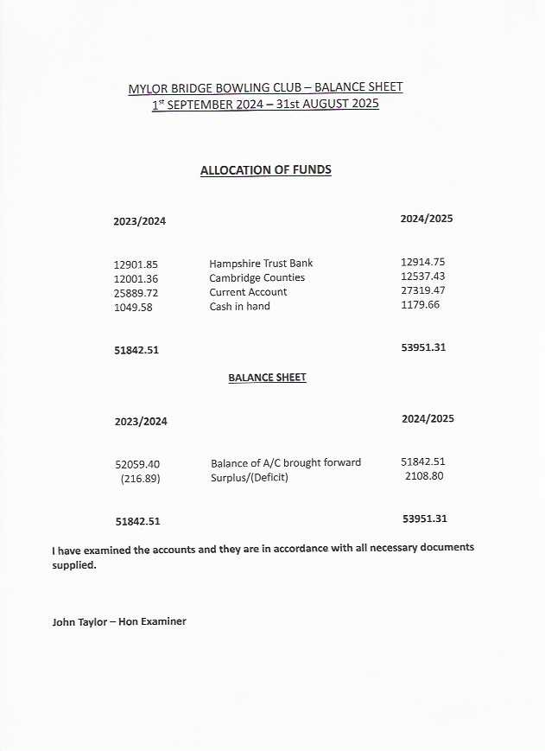

CLUB CAPTAIN’S REPORT

The Season has been one of mixed success in all Competitions. Congratulations to our Men’s ‘A’ Team who improved on their League position last year by one place, coming third in the Group 4 County League Division 1 with only Carnon and Chacewater above them. Our Men’s B Team began the season with a relatively inexperienced side losing some of last year’s team to the A side. However as the season progressed their results improved, which bodes well for next season. Our men also played in the Mining League Division and finished third to Chacewater A and Camborne A.
The Ladies Rippon A finished in a higher League position than last year coming 6th out of 17 teams and like the Men’s A had a more successful second half of the season. The Ladies Rippon B finished just below mid table but unfortunately various circumstances meant that they were unable to field a settled team and the same problems were experienced by the Date team who also finished in the second half of their table. Club members have also been playing in other Leagues – The Group 4 Mini League, The Ladies Evening League and the Strollers where at least 23 members have had the opportunity to play throughout the season.
In the Captains Shield the Men’s team were runners up in the Group 4 Final to Carnon and the Ladies were runners up in the Group 4 Semi Final to Chacewater.

Several of our members have been successfully flying the flag for Mylor Bridge in the Group 4 and County Competitions.
Carol Woodman was the Winner of the Group 4 Secretaries Final and David House won the Group 4 Secretaries Cup.
Sue Kelly won the Group 4 Final of the Kernow Cup with Sue Walker as the runner up.
Sue Walker reached the County Final of the Kernow Cup and was a close runner up and she also reached the Semi Final of the County Champions of Champions where she was an even closer runner up.
Sue Walker and Jeff Askew were runners up in the Group 4 Mixed Pairs Final.
Sue Walker and Sue Kelly reached the last 16 of the Bowls England National Foundation Pairs and were part of the Unbadged Group 4 team which won the County Final. They were also part of the Group 4 team who were runners up in the County Knockout Final.
Congratulations to Sue Walker who was selected to play in her first game for Cornwall this season and has therefore been awarded her Colts Badge.
After playing Bowls England last year when we celebrated our 50TH Anniversary we again welcomed Bowls England in May. We just edged a tight game winning by 9 shots overall. Very favourable comments were made about our Club in general and the excellent green reflecting on all those who help to maintain and run the Club as well as those who represent us on the green.
Our Sunday morning Roll Ups organised by our Committee members have been a great success with more new members joining the Club and providing an opportunity for existing club members to come along and play in a sociable and relaxed environment.
Our Charity Day in August was played in glorious weather. A good day was had by all, ably organised by Linda Storey. Forty members played and a good sum was raised for our two charities –Clean Ocean Sailing and Cornwall Air Ambulance.
Our Friendly fixtures both Indoor in the winter and Outdoor in the summer provide all club members with the opportunity to play. Our Indoor games were played in a good spirit but unfortunately the lack of a local indoor rink for practise was reflected in our lack of successful results. However our Outdoor Friendlies resulted in 5 wins and 2 losses.
Captains Day traditionally marks the end of the summer bowls season. Fifty members were in attendance and there was an excellent atmosphere despite the appalling weather. Congratulations should go to those who bravely faced the elements and played a few ends, getting soaked in the process.
Our Annual Club Tour was a tremendous success. Thanks are due to Elaine Beckton and Dave Jenkin who organised everything. A win v Hay On Wye, a draw v Croesyceiliog and a loss to Ross On Wye. Next year we are off to Worcester so come and join us!
As Club Captain I appreciate how important it is that the membership fully engage in the Club and it’s activities. Without our Committee Members, Coaches, Website Administrators, Greenkeepers, Gardeners, Working Party, Cleaners and Catering Team we would not be able to play the game we love or be able to provide such excellent facilities for the rest of Cornwall’s bowlers to enjoy. (At the time of writing this Report we have two important positions still available – Ladies Rep and Catering Officer.)
Our successes at Group and County level this season means that other clubs in the County are aware that Mylor Bridge is a competitive Club. Let’s continue in this vein. We have already had more members entering the National/County Competitions next year than last year so let’s keep the successes flowing.

Mylor Bridge Bowling Club – website review for AGM 2025

The objective for 2025 was to further increase the take up of online services, and further develop the level of interaction, making this the first point of reference for all members and replacing dependency on noticeboards. We believe this is still the only, fully interactive site in the county, with automated response and request in fixtures, rink booking, joining, user profiles, directory, club locations, and more.

In terms of fixtures, the ability for managers to enter teams, and for players to confirm their availability online, is now viewed as the ‘normal’ method of managing team selection.

The ability for the fixture system to be used in dual modes, provides a way of registering your interest for ‘open’ fixtures, such as friendlies. This allows teams to be selected from lists of members who have pre-registered their availability, helping to ensure that everyone gets match opportunities.

A further enhancement to the fixture system, is the ability to include food or other options within the fixture availability process. This has been successfully tried out on a few occasions and will be put into practice more fully next season.

The introduction of booking ‘windows’ controls the dates within which certain fixtures or events can be reserved, thereby enabling such events to be properly managed.

The rink booking system also operates in dual modes; outside rinks in the Summer, and indoor mats in the Winter. This has proved itself invaluable, particularly for club matches, which have ‘play-by’ deadlines. The integration between the fixture list and booking system, prevents over-booking of the green or mats when matches are scheduled, by removing those times from the available ‘slots’. The structure of booking slots has been changed to create one hour increments, making the system more flexible and maximising available booking times.

Enhancements to the site include the ‘Stop Press’ headlines; reminders on the home page of events or other notifications requiring member’s attention, usually with a link to the page with full details. The home page itself has been made less formal and ‘wordy’ with photos interspersed in the text, whilst the slide show now includes photos which show more casual play, in order to present a more inclusive and less stereotyped image.

Along with the above, there are a number of actions which members should take, if not already done so, as follows:

Look around the site and familiarise yourself with what’s included and where to find it. Many members don’t know how to find another member’s phone, email or address details. Did you know there are contact details, addresses and maps for every club in Cornwall? Laws and etiquette of the game are included. You can find the cleaning rota and check out the latest news items, as well as much more. Just have a look round.

Very few members contribute news or other items of interest. They will always be considered for inclusion, as will photos for publication in the club’s gallery. Just ensure you have the relevant permissions.

Finally, and most importantly, check your ‘profile’ and correct any errors. The member, not the club, is responsible for the accuracy of personal information (just like any other site you subscribe to). Web admin cannot see your password so, if you don’t know it or have lost it, we can reset it to a generic one, which you can then change to your own. Whilst in the profile area, why not add your photo. There are quite a few new(ish) members, and It’s useful to put a face to the name.

If you have any dificulties with any of the above, get in touch and we’ll be happy to help. Similarly, if you’re unable to log on to the site, we can help you there too.

JohnFrench 07890 277110

Ian Dodd 07721055903

